ACTIVITY NUMBER 1

Name: 1. Date:
2.
3.
4.
5.

Direction: Fill in the diagram with solutions on how to take care of our environment

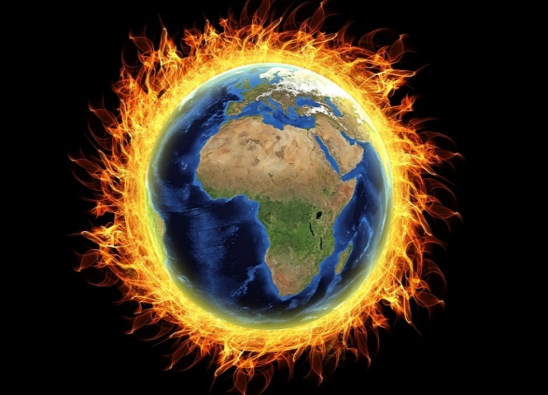
.
GLOBAL WARMING

